Start Sheet for the
Northampton & District Cycling Association
10 mile Time Trial (TT Series Event 2 of 8)
Saturday 20th April 2024 starting at 2 pm | FOUNDED 1935
 | PRESIDENT:
Promoted for and on behalf of Cycling Time Trials under their Rules and Regulations | Sue Holliday
This event is a counting event for all categories of the N&DCA Time Trial Series Championships.
For the latest points tables visit the results website: http://www.northamptondca.org.uk/

Headquarters:
Rockingham Forest Wheelers Clubhouse, 11 Ashley Road, Middleton LE16 8HR

Facilities:
The HQ will be open from just after 12.30 pm for toilets and sign on.
On the day parking is in the field past the clubhouse, it will be signposted. Please do not park on the road junction directly oppose the clubhouse.

Timekeepers: Sharon Fensom and Sue Holliday

Event Secretary: Phil Wilkison sarnbach@gmail.com

Please note that:
Prize Values | Handicap Prize
1st | £15
2nd | £12
3rd | £10
4th | £ 8
5th | £ 5

The handicap prize for this event is based on best improvement against predicted Spindata times. In the event of no Spindata prediction being generated which might be the case if not many events have been ridden recently, the time to beat will be the rider’s PB for 10 miles as supplied by the CTT entry form data. To be eligible for this prize competitors must have a 10 mile best time to beat.

Spot prizes: A spot prize will be awarded to every 10th place finisher on actual time (regardless of machine type) ie 10th, 20th, 30th, 40th, 50th, 60th place etc.

Local Regulations:

NO U-TURNS are allowed within sight of either the start or the finishing points. Riders carrying out this dangerous manoeuvre are liable for DISQUALIFICATION from the event and further disciplinary action by the district committee.
Please also remember that there is a need for good behaviour and consideration towards other road users and local residents in order to avoid any complaints being received.

Numbers:

These will be available at the Event Headquarters, not at the Start. Each number will have pins in each corner, please remove and place in box if not needed because you are using a NoPinz pocket. Also only use the corner pin holes and do not make more holes if using pins. Please ensure that the body number is clearly visible from behind and fixed on the lower back.

Signing In/Out:
Please ensure that you sign the “Signing-On” Sheet when collecting your number and clearly call out your number when crossing the finish line. Please ensure you return your number to HQ and sign-out, using the “Signing-on/off” Sheet. Failure to do so could result in your exclusion from the Results.

Road Bike category

For your ride in this event to be eligible for the season long Road Bike category it is assumed that your entry category covers the actual bike you are riding on the day. The start line assistant will check your bike meets the road bike criteria at the same time as checking lights. To be eligible your bike must not have “tri-bars” or equivalent, disc wheels, less than 12 spokes or other fairings. In event of a dispute regarding RB eligibility, the organisers decision is final.

Compulsory Front/Rear Lights and Helmets:

Regulation 14(i) requires all Competitors to have affixed to the rear of their machine a working rear red light, either flashing or constant, that is illuminated and in a position that is clearly visible to other road users.
Regulation 14(j) requires all Competitors to have affixed to the front of their machine a working front white light, either flashing or constant, that is illuminated and in a position that is clearly visible to other road users.
Regulation 15 requires that all Competitors must wear a properly affixed helmet which must be of hard/soft shell construction. Helmets should conform to a recognised Standard such as SNELL B95, ANSI Z90.4, AUS/NZS 2063:96, DIN 33-954, CPSC or EN 1078.
Failure of any of the above three points will render the competitor not being allowed to start the event.

Doping Control:

This event may be subject to Doping Control. As soon as you have finished you should return to HQ as it is your responsibility to check if you are required for a Doping Control. Race numbers required for Doping Control will be displayed at the HQ adjacent to the Result Board. If your number is displayed you should report immediately to Doping Control which will be nearby. Remember, it is up to you to check and ensure you comply.

Ride to the Start Point:
From the Race HQ follow Ashley Road out of the village after around 3.4 miles you will reach Ashley proceed through the village to the junction of the B664 where you will see the start. Please allow 17 minutes to ride there.
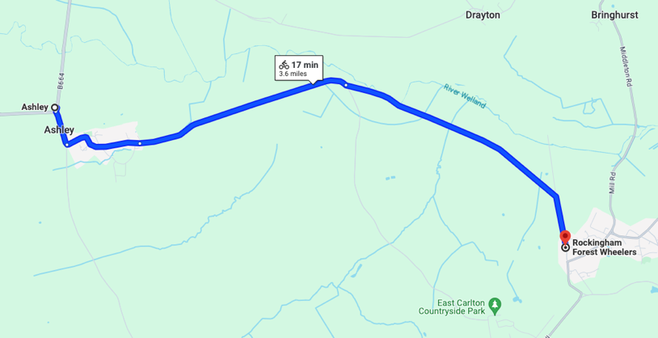

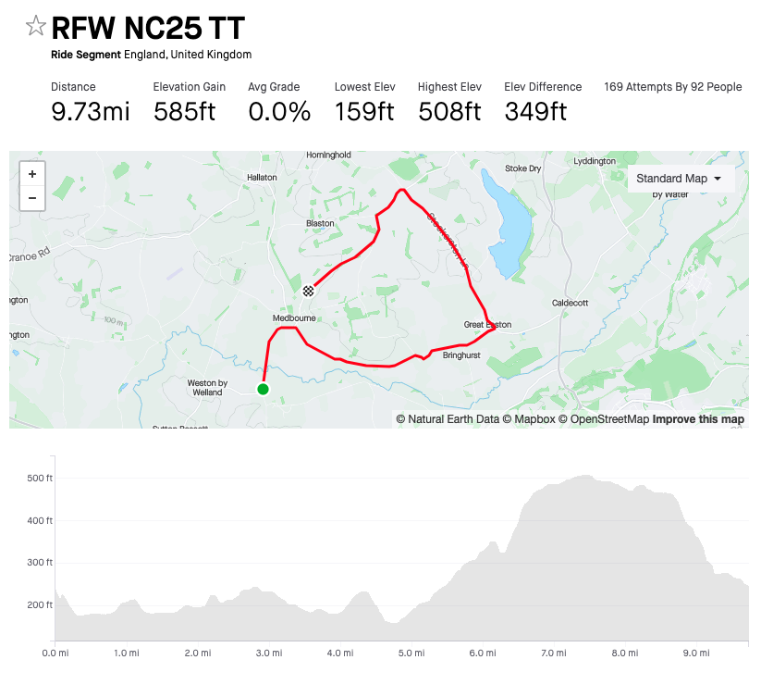
COURSE IDENTIFICATION: COURSE NUMBER NC25

This is a fairly new variation of the classic Devils Staircase RR course used for may years by the club. It’s not quite 10 miles but it’s near enough. The 0.2 mile missing is more than made up for with the climb of the iconic Devils!
Start is on the B664 you proceed through Medbourne, on to and through Bringhurst, arriving at Great Easton were at the junction (M) to take a left and start the climb up Stockerston Lane. At the crossroad at the top (M) you take another left onto the B664 heading towards Medbourne finishing at the ‘MEDBOURNE’ sign at the noth of the village 9.8 miles (ish).
N.B. In Medboune after 1 mile from the start there is a bridge and a sweeping right hand bend. Please do not feel the urge to cut the corner we will have an observer situated there and anyone found to be on the incorrect side of the road will be disqualified from the event.

COURSE NOTES:
The only motor vehicles associated with the Event allowed near Start or Finish will be those of the Timekeepers If passing any Horse Riders, please give due consideration and plenty of space.
Please refrain from warming up on the course after the event has started, as this causes extra work for the timekeepers.
Please keep well into the side, while waiting to start.

You must observe the Highway Code and comply with traffic law and regulations. You must also ride in a manner that is safe for yourselves and all others, and must rely on your own ability and judgement in dealing with hazards, though every effort has been made to marshal the course and the position of ‘Event Aware’ signs, so as to minimise the risk, as required by the Course ‘Risk Assessment’. The onus is still on you the rider, so familiarise yourself with the course details.

Competitors:
(A) = Association Club
Categories: S = Senior/Open F = Female J = Junior/ Juvenile
Masters Open: A = 50-54, B = 55-59, C = 60-64, D = 65-69, E = 70-74, F = 75 plus Masters Female: A = 40-44, B = 45-49, C = 50-54, D = 55-59, E = 60-64, F = 65 plus

*NB Masters age category is age on day of first N&DCA event ridden this year.

Juniors/Juveniles:
For the 2024 season there are no separate juvenile or junior sections, only a single U19 category, i.e. Those Competitors aged under 18 or have their 18th birthday during 2024

Result Sheet app:
Subject to availability of sufficiently tech savvy volunteers, we will be trialling the Result Sheet application which will enable you to track times live via the application on your phone if you scan the printed QR code at the Race HQ. Alternatively you can also view the results on screen at the HQ whilst enjoying tea and homemade cakes and some lively banter.

Season long competition prizes:
Please note that the actual value of the cash prizes awarded for performance in the various categories will be published after the last event of the season when the total prize fund is known as determined by the surplus generated by the event entry fee income.
Trophies:
Trophies and end of season competition prizes will be awarded at the annual Prize Award Lunch (usually held in January). NB Separate event prizes will be awarded after the last event in the series, not after each event.

The Association’s 12-hour trophies will be awarded to members of Association Clubs for their performances in any open 12-hour event held under CTT Rules & Regulations. The Association’s Long Distance BAR will be awarded to the highest placed rider of an Association Club in the National BBAR. Qualifying events are marked B in the CTT Handbook

For more information on the season long competitions and N&DCA trophies, including past winners, please refer to our website:

www.northamptondca.org.uk

Good luck and trust you all have a good and trouble free ride.

